**Game Development Documentation**

Group:

Radya / C14190043

Alycia / C14190056

Geraldy / C14190122

Agung / C14190074

Richard / C14180205

Devon / C14180209

**Role:**

Lead Project/Programmer: Radya

Programmers:

* Alycia
* Geraldy
* Agung

Lead Designer: Richard

Designer:

* Devon

Game title: Inferno Run

Game Genre: *Speedrunning*

Speedrunning is a type of game where the player runs toward the goal with the shortest possible time achievable. This type of game is meant to be played over and over to get the shortest amount of time possible. The focus of the game is on the movement system and level design. For this reason, the story tends to be simple because it is relatively irrelevant.

Target User: Speedrunner (15-30 thn)

This game is targeted at the speedrunning community such as “speedrun.com” and players who enjoy speedrunning games.

Theme: Inferno (9 circle of hell)

Game creation goal:

1. To fill in the player’s free time with a short 3D platforming game.
2. Self improvement. The Player uses and practices the movement mechanics available in the game to try and get the shortest time possible.

**Deskripsi Game**

A 3D platforming game that focuses on the movement system and level design. The story isn’t the focus of the game. The goal of the game is to reach the goal in the shortest possible time. There will be 9 levels in the game and the design took inspiration from “Dante’s Inferno”. Every level will have their own uniqueness, for example on floor 2, there will be gusts of wind that can push the player, on floor 3 there will be floors with slippery ice, etc.

Tujuan player bermain: Self Improvement

The main motivation of speedrunning games is self improvement with shorter time as proof that the player becomes better at the game. Learning new tricks and mechanics will improve the player’s skill at the game and enable them to reach a shorter time to finish a level.

**Gameplay**

There will be 9 levels in the game. The game is a 3D platformer. The player will need to use their movement skill to navigate through the level and reach the next level. The ultimate goal is to reach level 9 with the lowest amount of time elapsed.

**Plot**

Note : The plot is not the main focus of the game

Opening : "You just finished speedrunning through life, and now you're trying to speedrun through inferno to meet and get a selfie with the devil himself. Now run and go get that sweet picture to post on instapic!"

Ending : Player grabs a selfie with the frozen devil.

**Level design**

Player movement & abilities:

* Running
* Slide (goes faster downhill)
* Wall run (run fast on walls with increasing falling speed for each seconds that passed)
* Wall jump (jump from wall to wall, reset the wall run falling speed)
* Grappling hook

Level Design Plan:

1. Extra (Quality of life, low priority):

* Collectible items in stages, optional (easter eggs), stages can be repeated without collecting the collectible to get a better clear time while still keeping the collected item in the gallery
* A shadow that shows player’s movements from their best time
* Getting achievements after finishing the game
* UI where the player can see all achievements gained in the game.

1. Floor 1, Limbo:

* Tutorial stage, getting the player used to movements and game’s mechanics
* Shows every mechanic that will be used in later levels

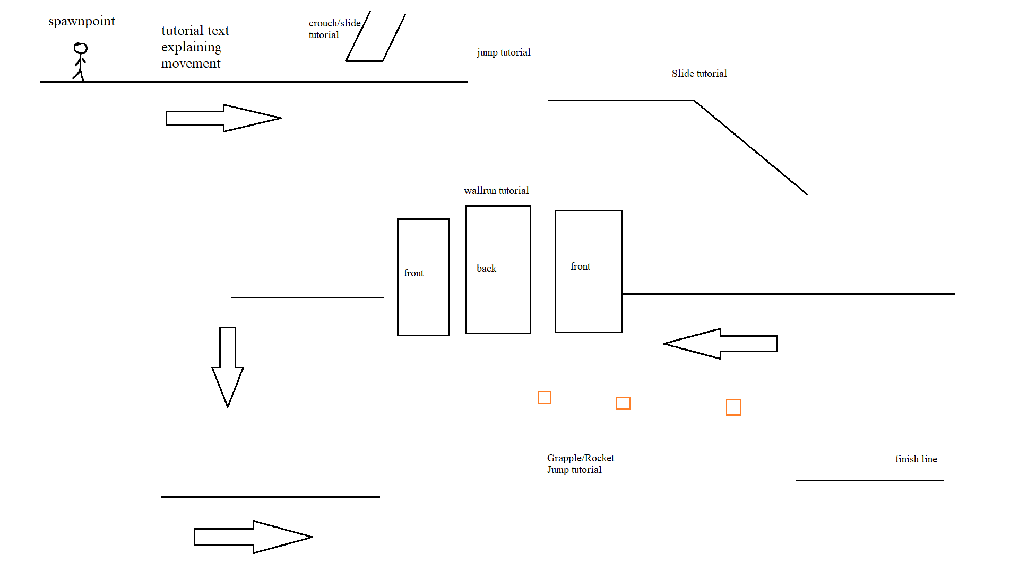

1. Floor 2, Lust:

* A wind would try to blow players off to a certain direction
* Tornado dragging player
* Wind tile / updraft giving jump boost

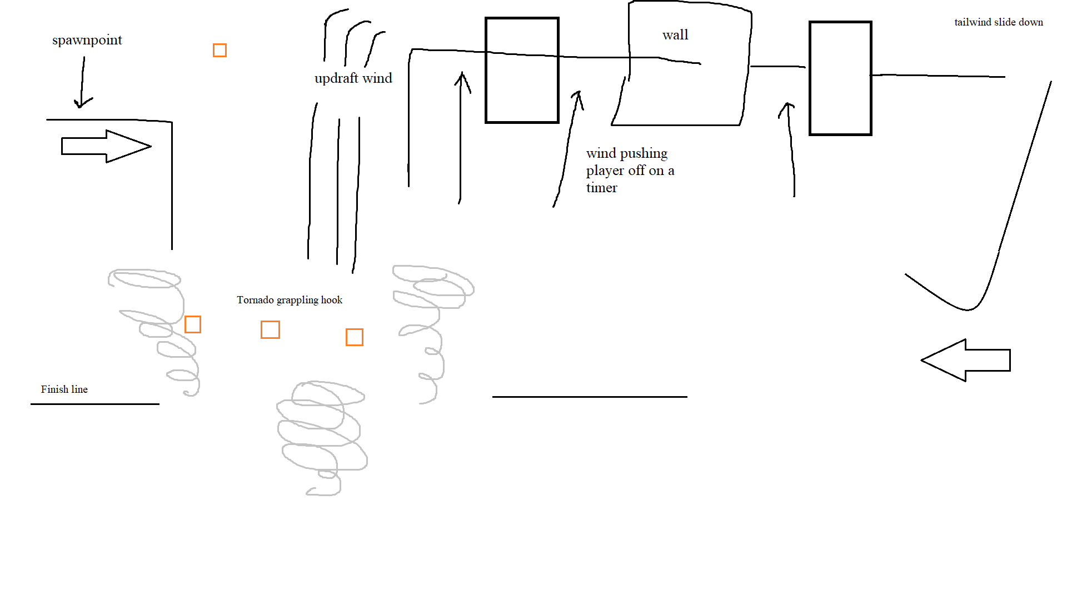

1. Floor 3, Gluttony:

* Icy floor (traveling/jumping horizontal speed could be affected by how long player has been running on the surface)
* Cracked floors that collapse if stepped on for too long.
* The player will die if they fall into the freezing water

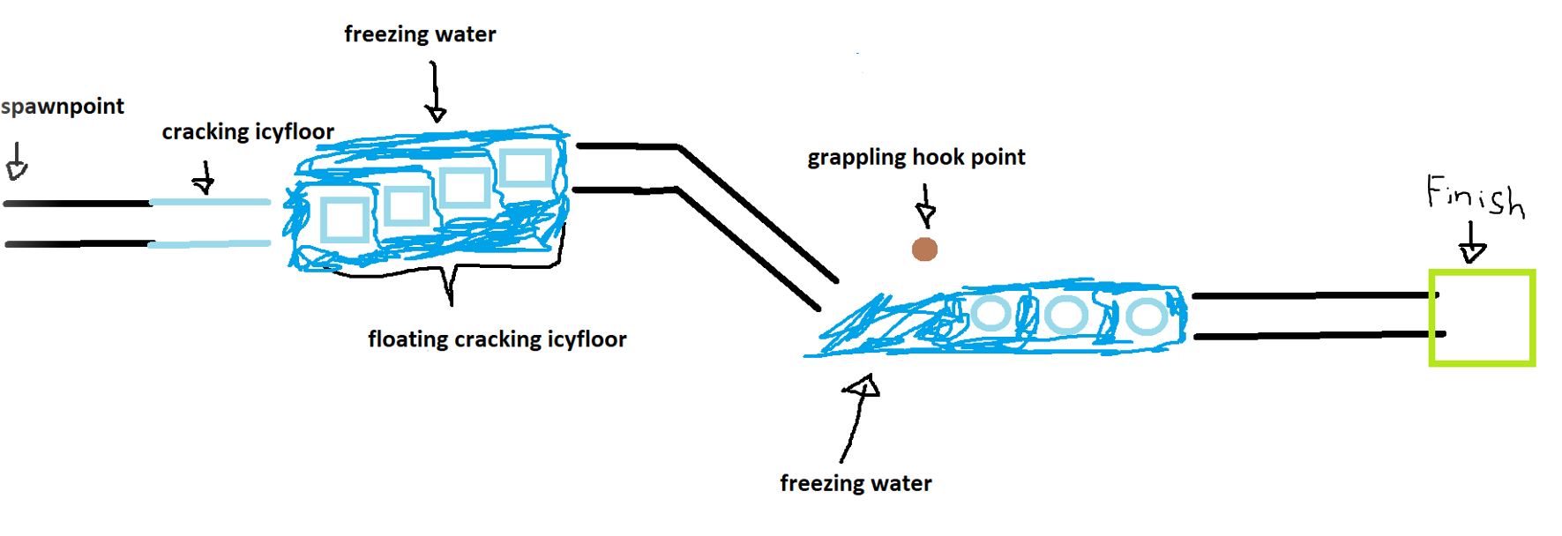

1. Floor 4, Greed:

* Player needs to find and collect 3 artifacts to open the door to finish the level.
* The first artifact is a linear path.
* The artifacts after that, the player can choose the easy path or the hard path
* The easy path takes longer time but safer, the hard path is shorter but more dangerous.
* The player will die if they fall into the fire or got hit by the spiky traps

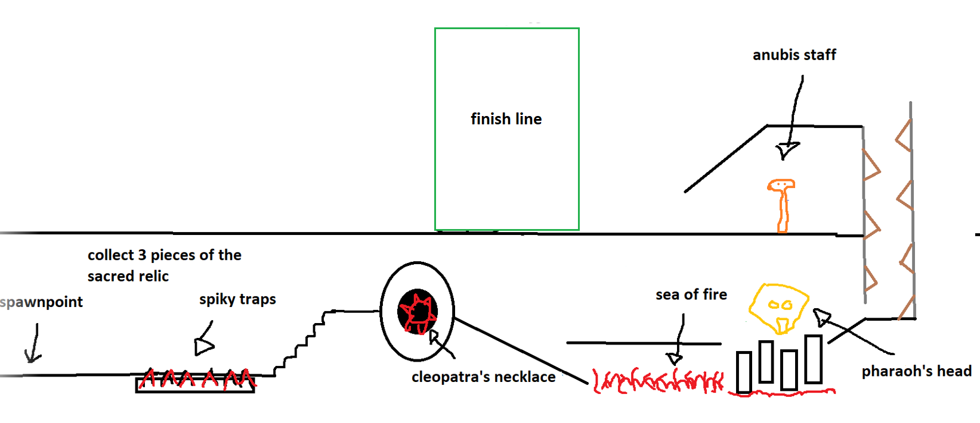

1. Floor 5, Anger:

* Swamp monsters from the swamp would try to attack the player
* Bog surface, slowing down player
* Monster limbs sticking out of the surface of the swamp, where if the player makes contact with it (touches it), the monster will pull the player into the swamp (restart level)

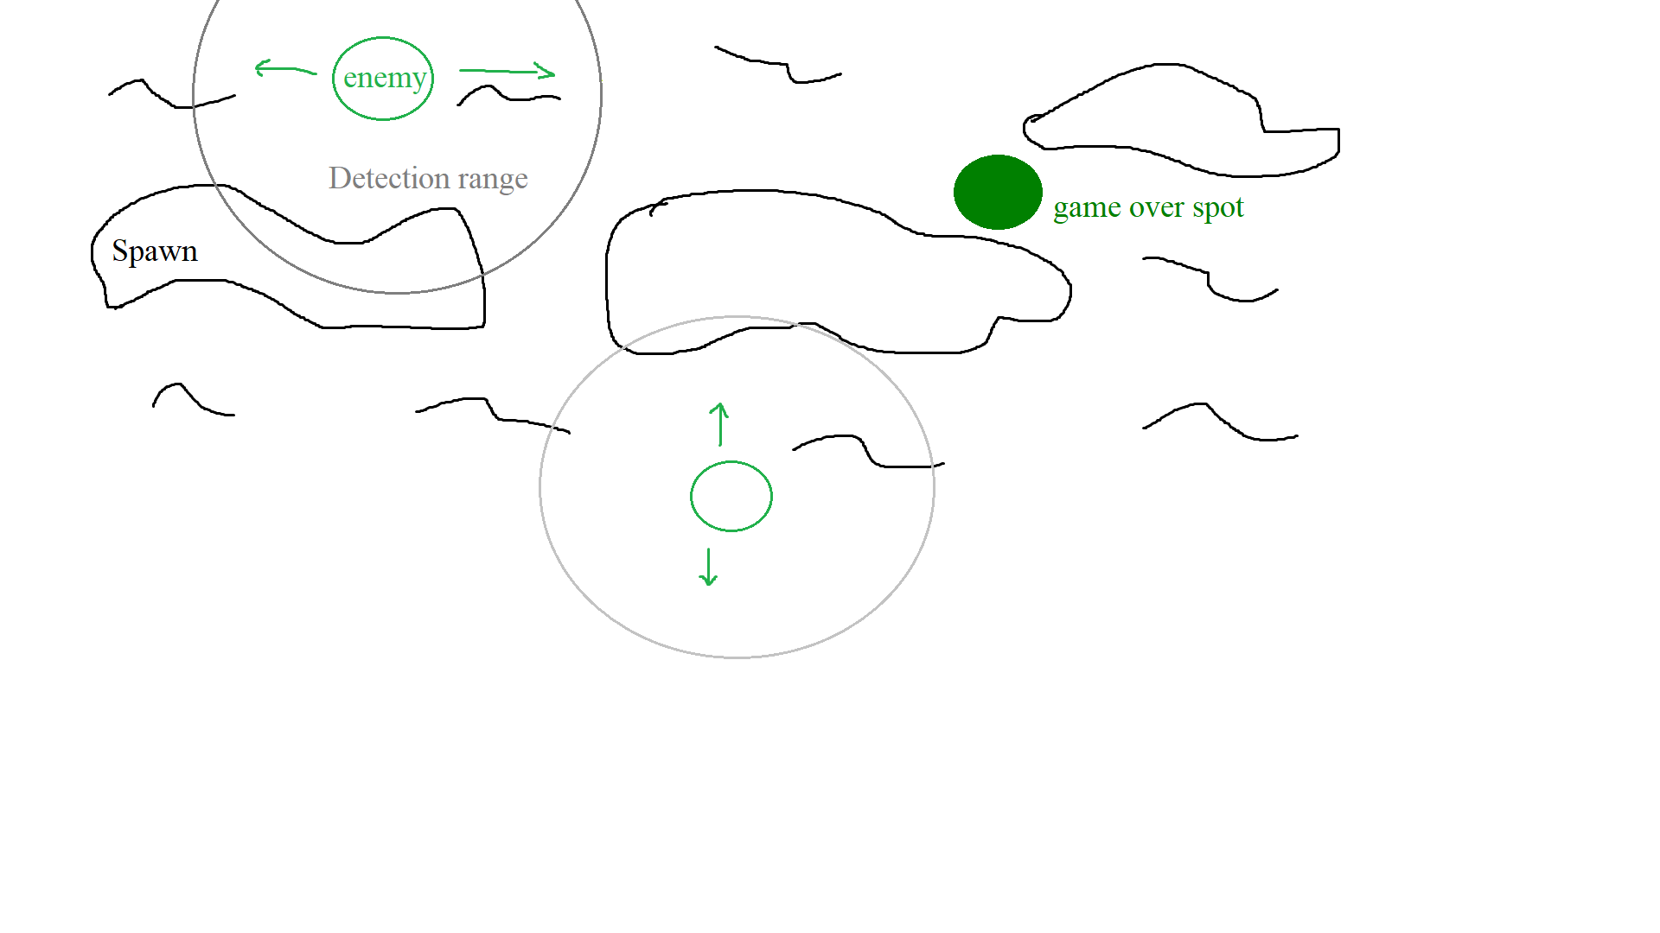

1. Floor 6, Heresy:

* Full of fire and lava
* The player will die if they fall into the lava
* Player parkour ability will be tested on this level

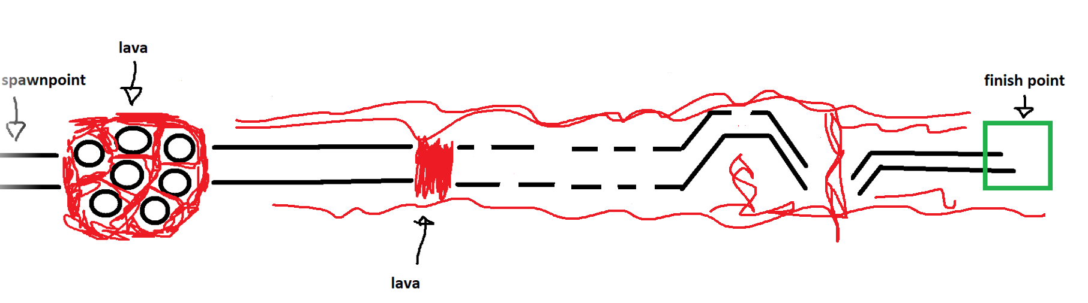

1. Floor 7, Violence:

* Rising liquid threatening to drown the player
* Vertical focused level
* Certain mechanics that will try to push/slice the player (traps/gimmicks)
* Later stages would involve platforms that will eventually crack and disappear after a certain duration after player lands on it

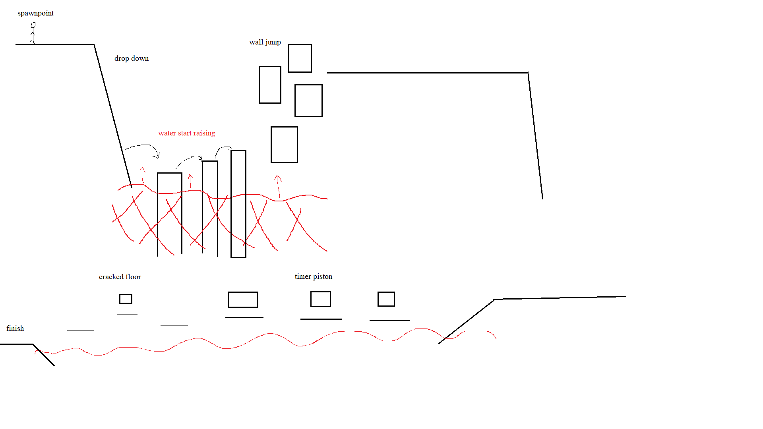

1. Floor 8, Fraud:

* Pintu ilusi, player bisa lanjut ke level selanjutnya
* A lighting mechanic where the stage could turn very dark, hence reducing the player’s visibility massively for a certain span of time before the lights return, making the player have to rely on spatial memory. (Happens when the ghost catches up to the player)
* Ghost chasing player
* Grappling focus

1. Floor 9, Treachery:

* Epilogue: Selfie with the devil

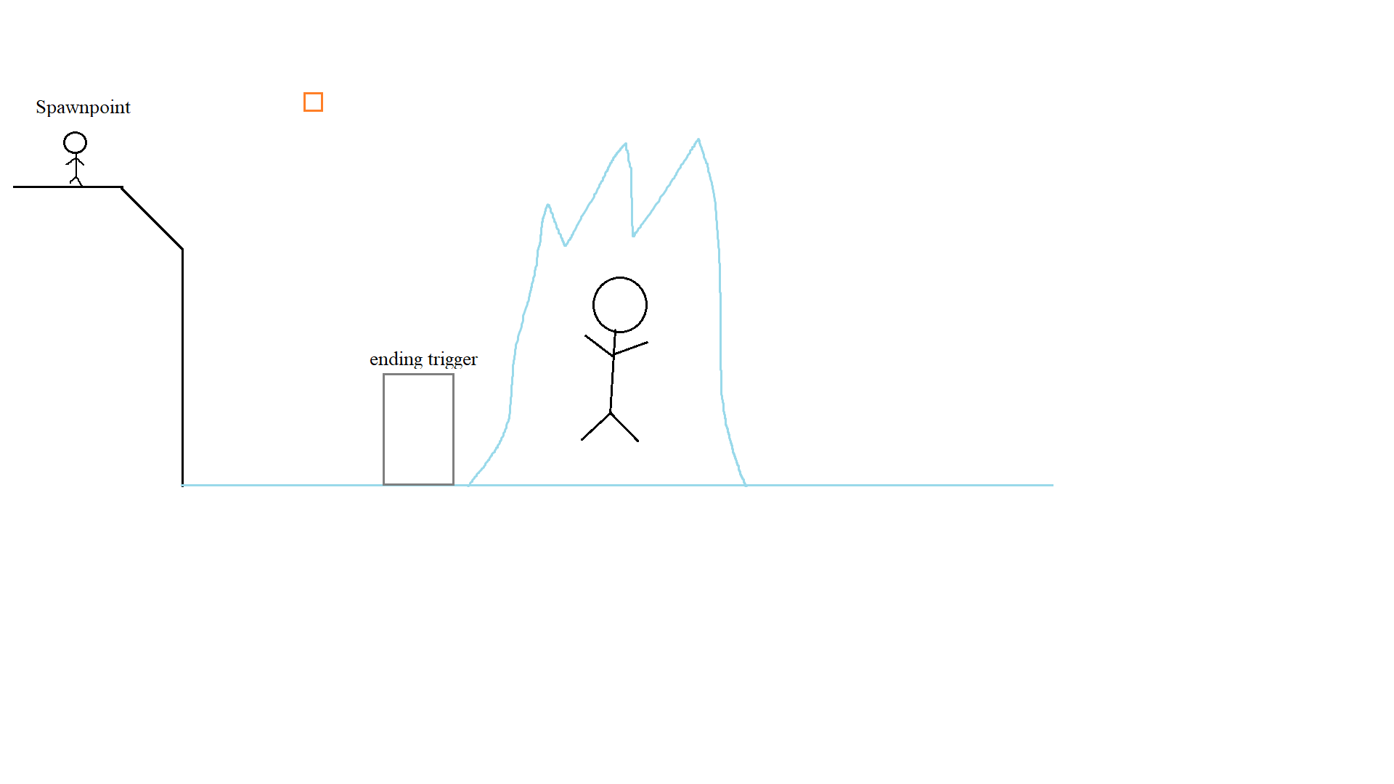

Character table:

| **Name** | **Action** | **design** | **If** |
| --- | --- | --- | --- |
| Player | Move, grappling hook |  | If dead then game over |
| Swamp Monster | Detect player, chase player | Like this, but green | If player in range then chase player  If collision with player then game over |
| Ghost | Chase player |  | If player collision then reduce player vision |

**Gamerule (Game Details)**

Player:

* Level start, timer start
* If player dies, give option restart or back to menu
* If player hit finish line, give option next level or restart
* Player dies if: player fell into a cliff, player gets hit by a projectile, player drowns, player fell into lava

Rough Draft Game UI:

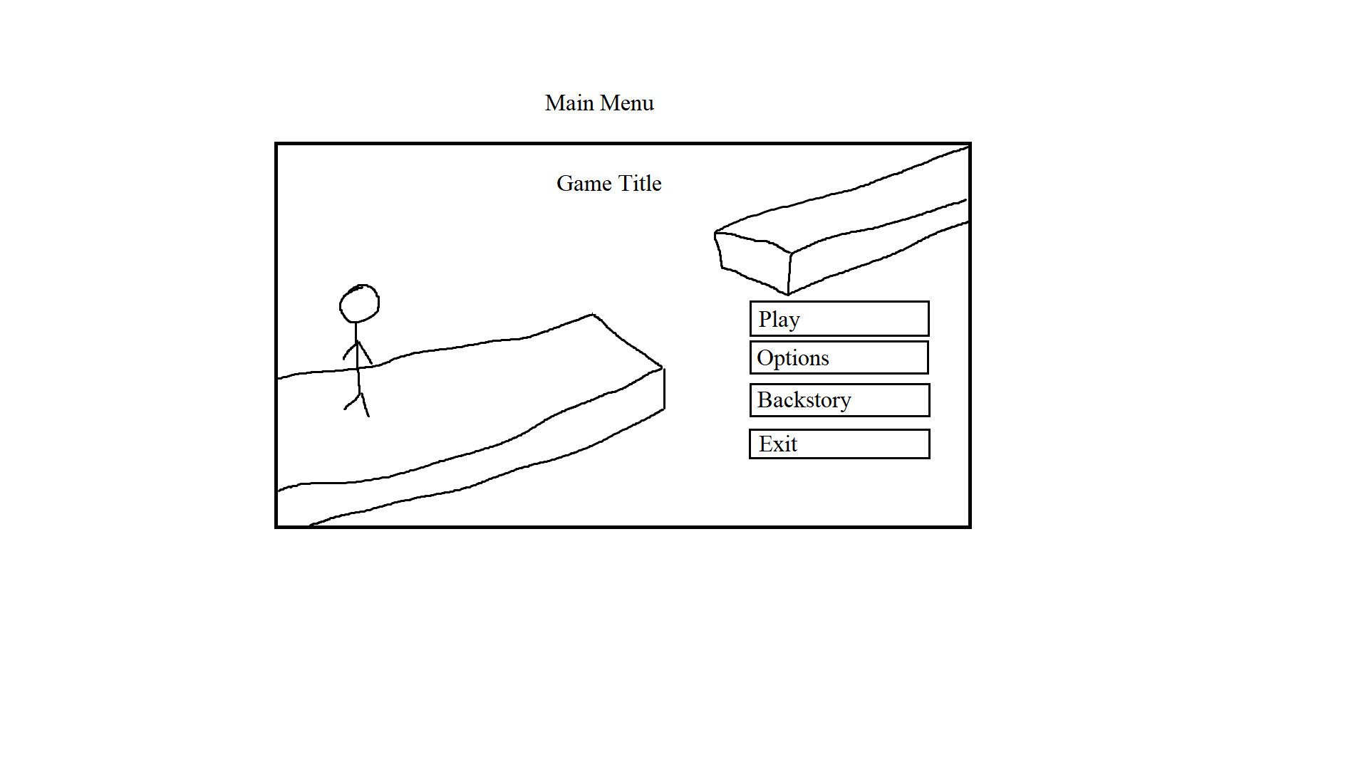

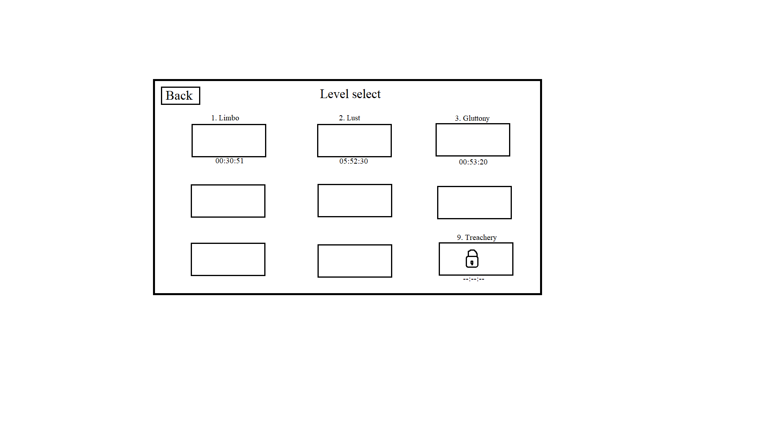

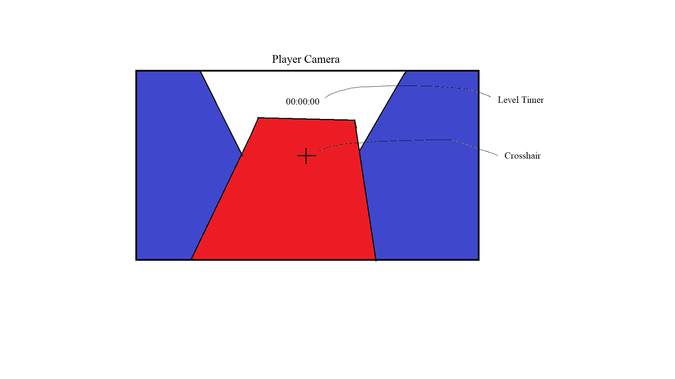

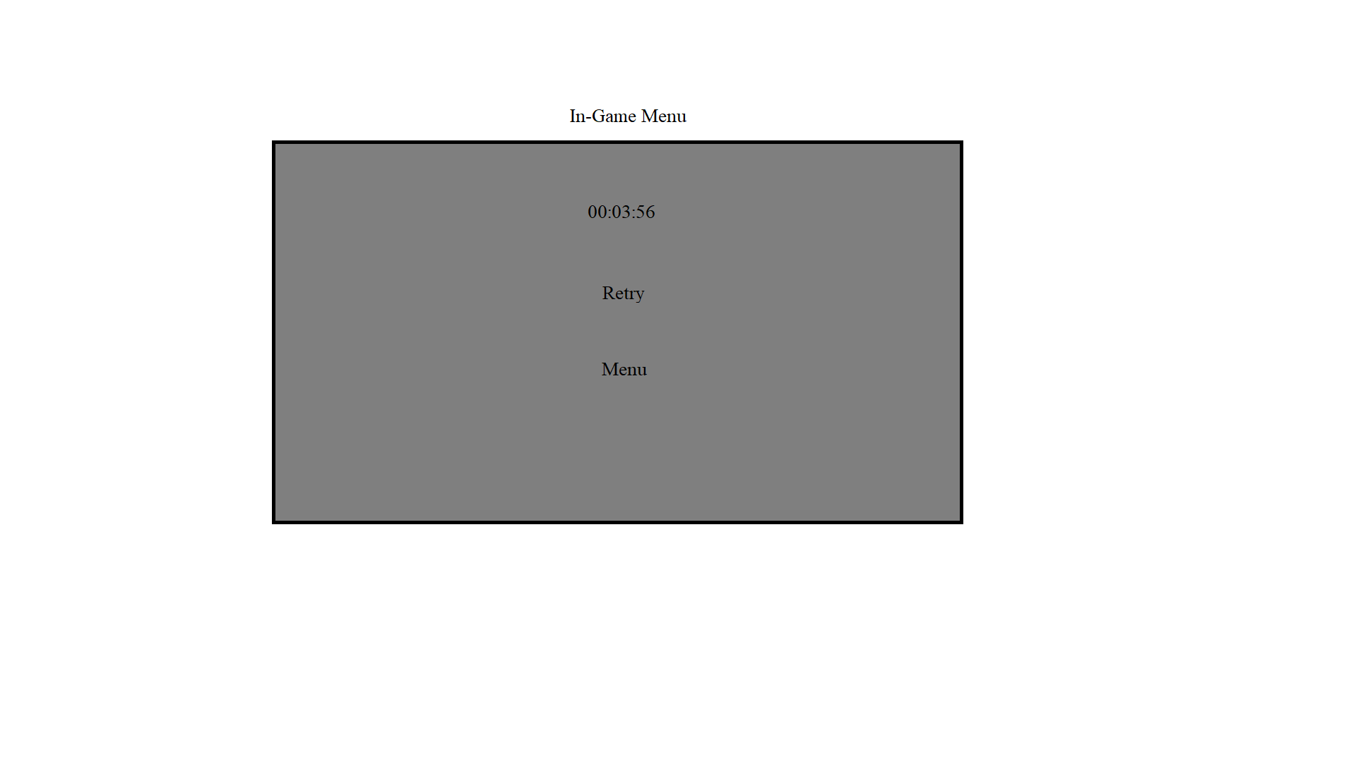

**Work Schedule (Deadline)**

17 October 2021:

* Player movement 100% done - Agung
* Player model and animation implemented - Radya
* Level mechanics 100% done - Alycia / Gerald
* Level environment 30% done - Richard / Devon

24 October 2021:

* Main menu 50% done (level selection and exit. Setting later) - Agung
* Sound fx 100% done - Radya / Alycia / Gerald
* Level environment 60% done - Richard / Devon

7 November 2021:

* Main menu 100% done - Agung
* Playtesting & bug fixing - Radya / Alycia / Gerald
* Level environment 100% done - Richard / Devon

21 November 2021:

* More playtesting and debugging
* Skybox done

30 November 2021:

* Quality of live implemented

Concept art: <https://docs.google.com/document/d/1aydh3wi1TJNr1o6myrcmcWmXyj2h_dHNyLfV7SVSlL4/edit>

Priority:  
1. Player Movement

2. Level Design

3. Environment Design

Referensi:

1. Karlson (<https://danidev.itch.io/karlson>)
2. Frost Runner (<https://store.steampowered.com/app/934840/FrostRunner/>)
3. Neon Boost (<https://store.steampowered.com/app/1057850/Neon_Boost/>)
4. Escape from naraka (<https://store.steampowered.com/app/1390670/Escape_from_Naraka/>)